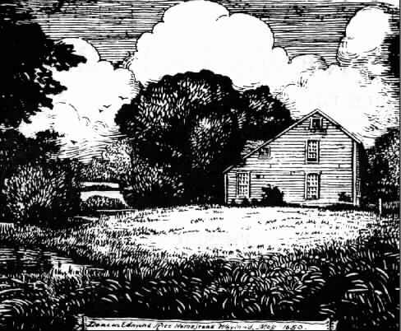
Edmund Rice (1638) Assoc., Inc.

Kathy H. Bond
ERA Membership Chair
31 Billings Road
North Stonington, CT 06359
membership@edmund-rice.org
r 1, 2009

Dear Cousin,
Annual dues are payable by September 1st $___________
Additional voluntary contribution $___________
Total $___________

The schedule of dues is as follows:
Under age 80 20.00
Age 80 and above 10.00
Life membership (in a single payment) 300.00

Membership Type: New _____ Renewal _____ Update ______

Preferred Newsletter Delivery Method: Paper via US Mail____ or Email____

Phone Number (_____) __________-______________

Email address _____________________________________________________

Birthday (MM/DD/YYYY) _____________________________________________
Added to ERA database for identification (kept confidential) and Birthday Wishes

Name ____________________________________________________________
Due to duplicate first & last names: Please include First, Middle, “Maiden” Last, Suffix

Address __________________________________________________________

City/Town/Province_________________________________________________

State _________ Zip/Postal Code ___________________

Country (if not USA) ______________________________

Note: Dues rate is per person; there is no discount for a spouse or children.
The Board of Directors voted to insert the "Additional Voluntary Contribution" line in an attempt to offset the erosion of our treasury due to the current low interest rates.
Your additional contributions are appreciated.

You may pay your dues via PAYPAL and then complete and submit this form to membership@edmund-rice.org. Make your check payable to Edmund Rice (1638) Assn., Inc., and send with form to:

Kathy H. Bond
31 Billings Road
North Stonington, CT 06359
membership@edmund-rice.org

